Jiangsu Sunzo – Specialized Electrolyzer Disc Spring Integrated Solution White Paper
— More than just products—we provide comprehensive solutions.

I. Company Profile
Jiangsu Sunzo is a National High-Tech Enterprise and a Provincial "Specialized, Refined, Unique, and Innovative" Enterprise. Since 2006, the company has focused on the precision research, development, and manufacturing of disc springs, participated in the formulation and revision of the national standard GB/T 1972 for elastic components, holds more than 70 spring-related patents, and has established a closed-loop industrial production base covering the entire value chain: custom processing of special raw materials precision forging of conical blanks specialized heat treatment according to specific operating conditions fully automated dimensional and force sorting operating condition simulation laboratory.
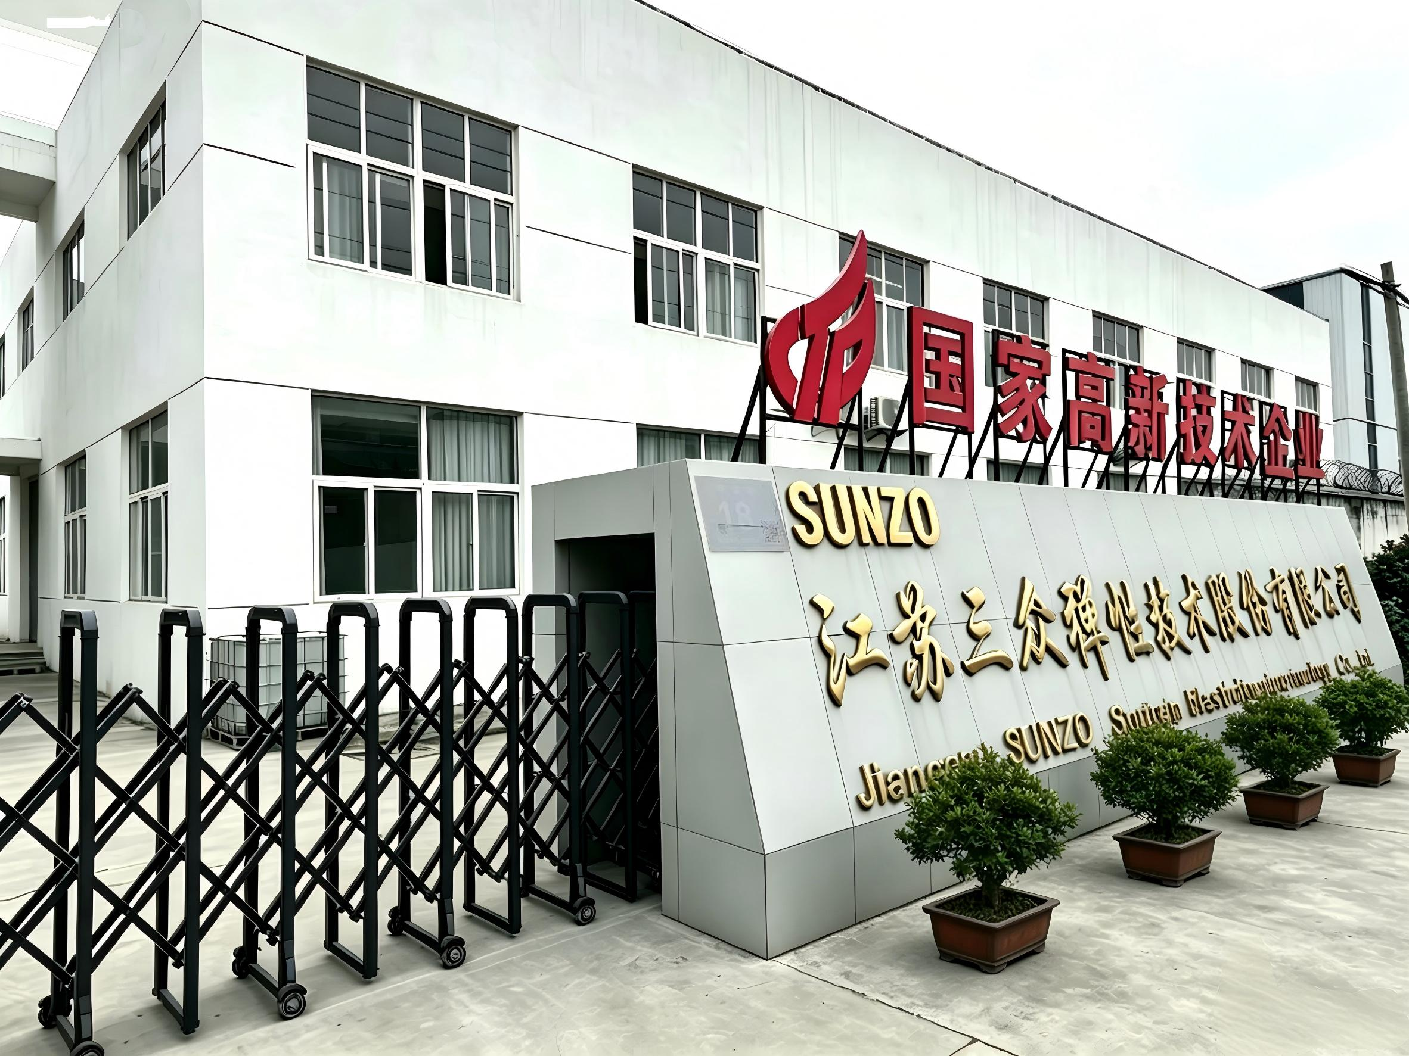

Core Qualifications and Production Capacity
- System Certification: ISO 9001, IATF 16949, ISO 14001, and ISO 45001 – covering the entire organization, enabling compliance with the stringent quality audit requirements for energy equipment;
- Comprehensive Testing Center: We have established a 100,000-class precision testing laboratory equipped with comprehensive test facilities covering load curves, high-temperature creep, stress relaxation, fatigue cycles, neutral salt spray, metallographic analysis, and hydrogen embrittlement stress testing; we are capable of independently conducting full-fledged factory acceptance testing, providing complete internal test reports, and supporting third-party institutions in performing external certification tests;
- Full-range material inventory: We maintain a consistent stock of specialized hydrogen energy materials, including refined spring steel, austenitic stainless steel, Inconel nickel-based superalloys, precipitation-hardened stainless steel, and Hastelloy corrosion-resistant alloys, with rapid response capabilities for both sample and batch deliveries;
- Supporting service capabilities: standard specifications with in-stock inventory; non-standard disc springs available for custom orders starting from a single unit; complete sets of factory-type testing support; on-site engineering assembly technical guidance; and long-term failure analysis support.

Core Positioning of the Green Hydrogen Sector
We focus on the three mainstream electrolyzer clamping systems: alkaline ALK systems, PEM proton exchange membranes, and AEM anion exchange membranes. To address five critical extreme operating conditions—continuous high-voltage pre-clamping, cyclic thermal cycling, hydrogen embrittlement/strong alkali corrosion, long-term high-temperature creep, and stack sealing safety—we provide integrated disc spring clamping complete solutions tailored to meet the localization requirements for clamping systems across various hydrogen production equipment.

II. Background of the Green Hydrogen Industry: The Core Value of Electrolyzer Disc Springs and Common Industry Pain Points

2.1 The four core functions of diaphragm springs in electrolysis cell stacking systems

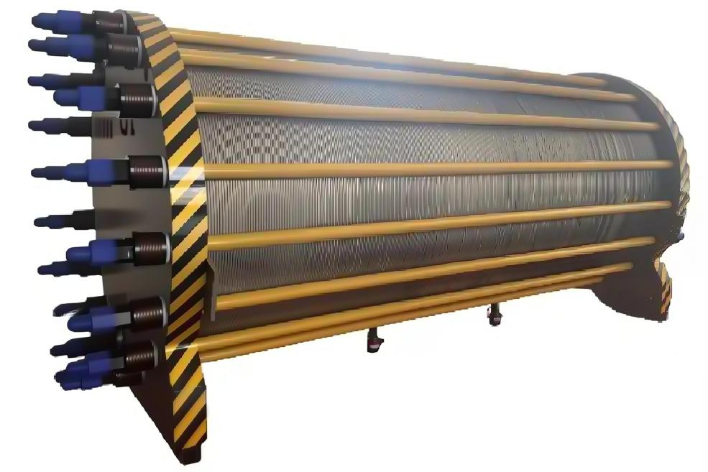
- Uniformly distributed uniform preload
- Balances the clamping of the electrode plates, the membrane electrode assembly, and the sealing gaskets; eliminates local pressure voids within the fuel cell stack; reduces the contact resistance between the electrode plates; stabilizes the hydrogen production energy consumption; and prevents localized overheating.
- Long-term creep dynamic compensation
- The compensating sealing element and electrode plate material counteract creep relaxation under long-term operation at high temperatures and high pressures, thereby continuously maintaining the stack's clamping load and preventing a sustained decrease in operating pressure.
- Cold/Hot Start Adaptive Buffer
- It is designed to withstand the drastic temperature fluctuations caused by frequent power-on and power-off cycles of the equipment, compensates for the dimensional expansion and contraction due to thermal effects in metals, and eliminates both sealing leakage under low-temperature operating conditions and membrane module crushing risks under high-temperature operating conditions.
- Comprehensive safety sealing guarantee for equipment
- The continuous and stable compression of the sealing structure effectively prevents major safety hazards such as alkaline electrolyte leakage and hydrogen-oxygen medium mixing under high-voltage operating conditions at their source.

2.2 Common failure points of disc springs in electrolysis cells across the entire industry
- Poor force consistency
- The thickness and free height of the disc springs within the same batch exhibit significant tolerance variations; the preload load at multiple bolt points for each individual fuel cell stack shows large deviations; the pressure distribution across the stack is uneven; contact resistance fluctuates; and localized high temperatures occur.
- Severe high-temperature long-term stress relaxation/creep
- After several months of continuous operation, the preload of the equipment may experience a significant reduction; in such cases, the unit must be shut down for disassembly and re-tightening of the bolts, which interrupts production, substantially reduces the operating rate of the electrolysis cell, and increases operational and maintenance labor costs.
- Hydrogen embrittlement and strong alkali corrosion failure risks
- Alkaline electrolyzers are exposed to KOH-based strong alkaline electrolyte over long periods; PEM electrolyzers operate in a high-pressure hydrogen environment, where conventional carbon steel and standard spring steel are prone to surface corrosion and internal hydrogen-induced cracking, thereby posing potential risks of fracture and leakage.
- Insufficient fatigue life
- Under frequent start-stop cycling conditions associated with project auxiliary equipment, disc springs are prone to fatigue fracture, which can directly lead to sealing failure and safety incidents involving medium leakage.
- Surface friction generates metal debris.
- Long-term reciprocating friction between the disc spring and the terminal plate generates metal powder, which contaminates the electrolyte, scratches the membrane electrode, and, in severe cases, causes breakdown of the insulation structure.
- Shortcomings in traditional imported supporting components
- Overseas disc spring brands feature long delivery cycles and relatively high product pricing; they do not support small-batch customized development, lack on-site technical engineers in China, and are unable to perform specialized process optimization tailored to the unique operating conditions of electrolysis cells.

III. Breakdown of Operating Conditions Requirements for Typical Electrolyzer Equipment Customers

3.1 Overview of the Client Company
The client is a leading domestic manufacturer of complete electrolyzer systems, simultaneously deploying two production lines—one for alkaline ALK electrolysis and another for its proprietary PEM membrane technology; its product portfolio covers large-scale industrial hydrogen production units as well as medium-to-large high-pressure hydrogen production equipment, primarily targeting large-scale industrial green hydrogen production scenarios.

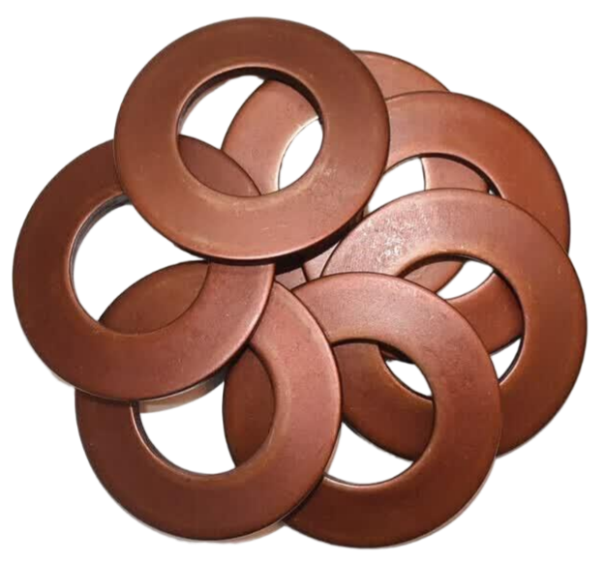
3.2 Current on-site application conditions for disc springs

- Product specifications: Large outer diameter heavy-duty disc spring; its inner and outer diameters and thickness fall within the general heavy-duty size range for high-power electrolysis cells;
- Original supporting materials: conventional spring steel;
- Assembly configuration: A multi-piece stacked assembly arranged on the outer side of the end plate, utilizing a matching positioning slot structure to achieve radial limiting;
- Electrochemical stack fastening structure: a central tensioning layout utilizing multiple tensioning bolts, with uniform clamping applied to each individual stack;
- Operating conditions: The equipment is designed for a high clamping load, with the compression ratio of the disc spring assembly approaching the extreme compression range;
- Current operational status: The product's design service life is long; however, during operation, significant creep-induced degradation occurs, necessitating occasional shutdowns to retighten bolts and compensate for pressure loss.

3.3 Customer Core Technology Pain Points
- The dimensional tolerance control for externally purchased disc springs is lenient; within the same batch, there are significant fluctuations in free height and thickness; after stacking, the load deviation exceeds the specified limits; consequently, achieving satisfactory pressure uniformity across the stack proves challenging.
- Under high-load-limit compression operating conditions, the material exhibits significant creep behavior, and frequent shutdowns for re-tightening lead to a loss of production capacity;
- Under PEM high-pressure hydrogen operating conditions, conventional spring steel exhibits insufficient resistance to hydrogen embrittlement, posing a fracture safety risk during long-term operation;
- Traditional standardized supporting products cannot optimize the cone billet's structure or heat treatment process to meet the customer's heavy-duty operating conditions, nor do they offer customized solutions;
- Supplier qualification requirements mandate a full set of type tests; however, these tests involve lengthy durations, and their extended delivery timelines can easily delay the project's commissioning schedule.

3.4 Customer Selection Criteria Priority
① Load stability ② Dimensional consistency ③ Low permanent deformation / Creep resistance ④ Fatigue life

3.5 Key Customer Collaboration Requirements
- Optimize the overall supporting procurement cost under the premise of equivalent performance specifications;
- By upgrading the manufacturing process, the dimensional tolerances of the disc springs are reduced, thereby improving the load consistency within the same batch;
- Provides a complete set of factory-type test and inspection data, fully meeting the requirements for the customer's internal access audit;
- Opening up joint development channels to specifically address the industry challenge of long-term creep relaxation in high-load composite disc springs.

IV. Customized Full-Solution Package for Overloaded High-Preload Electrolysis Cell Disc Springs
To address the high-load, multi-sheet stacking, and extreme compression operating conditions inherent in high-power electrolyzers, Jiangsu Sunzo has introduced a specialized integrated disc spring solution designed for heavy-duty, low creep resistance against hydrogen embrittlement, providing comprehensive coverage of all technical challenges faced by customers.

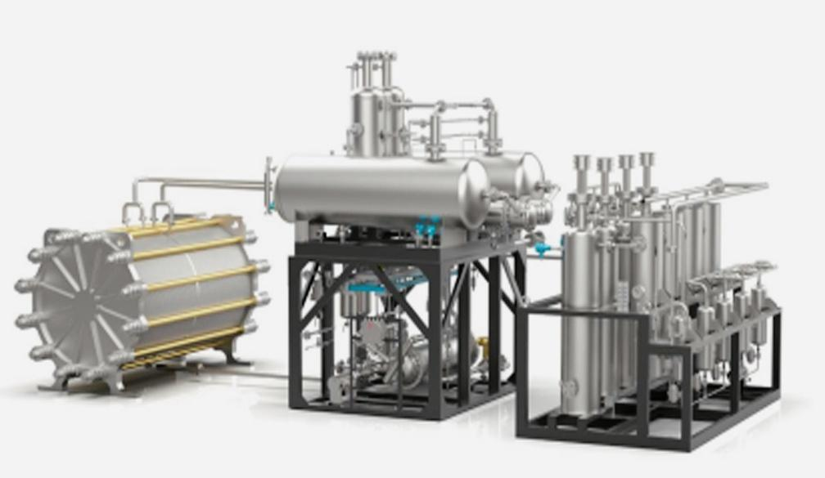

4.1 Dual-Line Material Upgrading Solution

Option A: High-purity spring steel series specifically designed for alkaline ALK electrolysis cells
Utilizing ultra-pure spring steel raw materials combined with a proprietary quenching and tempering heat treatment process, this product employs a standardized production workflow to rigorously ensure excellent resistance to strong alkali corrosion, low creep properties, and cost-effectiveness for large-scale equipment applications, making it ideal for continuous hydrogen production systems with large standard volumes.

Option B: PEM High-Pressure Electrolyzer Spring Steel Disc Spring Series
This product utilizes high-quality spring steel substrate paired with a Dacron corrosion-resistant coating, combined with a standardized surface treatment process to resist moisture and corrosive media; it effectively controls high-temperature stress relaxation, making it suitable for high-pressure hydrogen environments and conditions involving frequent start-stop cycles, thereby ensuring long-term uniform compression of the proton exchange membrane, mitigating the risk of elastic failure during prolonged operation, and supporting integration with membrane electrode insulation solutions.

4.2 Special Optimization Plan for Dimensional Tolerances
- The precision forging process for conical blanks features strict control over the flatness of the disc spring support surface, with thickness tolerances that exceed industry general standards;
- A fully automated full-assembly load sorting system for finished products; the disc spring load deviation within the same batch is controlled within ±3%, significantly improving the overall pressure uniformity of multi-bolt stacks;
- The dimensional closed-loop control system is designed to match the positioning slot structure of the client plate, ensuring assembly without jamming or radial displacement friction, thereby reducing the generation of end-face wear debris.

4.3 Optimization Design of Composite Hybrid Structures
- The finite element-based multi-physics field simulation is employed to simulate the force-displacement curves of multiple stacked components, optimize the conical taper ratio of the disc springs, and prevent stress concentration-induced cracking under extreme compression conditions;
- The disc spring contact surfaces are coated with a dry low-friction and wear-resistant coating, which reduces mutual frictional losses between the laminations, prevents the shedding of metal debris, meets the clean-medium operating requirements for hydrogen production equipment, and eliminates the need for assembly lubrication grease;
- The load curve is matched to the customer's specified clamping force range, significantly reducing the creep attenuation at the ultimate compression level and substantially extending the bolt retightening cycle.

4.4 Full set of type test results and corresponding delivery
Complete sets of internal testing reports will be provided simultaneously with the test samples and batch products; these reports may include a comprehensive suite of test data, such as: metallographic microstructure of raw materials, hardness testing, load–deformation characteristic curves, 10,000-cycle fatigue life testing, 1,000-hour neutral salt spray corrosion testing, high-temperature creep relaxation testing, and hydrogen embrittlement stress testing; if third-party authoritative testing is required, we can assist the client in coordinating with external testing institutions to conduct the tests.

4.5 Exclusive Technical Support Package
- Free simulation of the fuel cell stack clamping force, outputting the optimal number of disc springs and the corresponding configuration selection scheme;
- Engineers provide on-site assembly guidance, delivering standardized composite assembly workflows and pre-tightening torque calibration specifications;
- Free disassembly and failure analysis for product operational anomalies; provides a process iteration and optimization plan;
- Establish dedicated collaborative R&D channels to continuously iterate product processes and address industry-wide common challenges such as heavy-duty creep and hydrogen embrittlement.
- Sunzo Electrolyzer Disc Spring Product Portfolio: ALK/PEM/AEM – Full-scenario compatibility

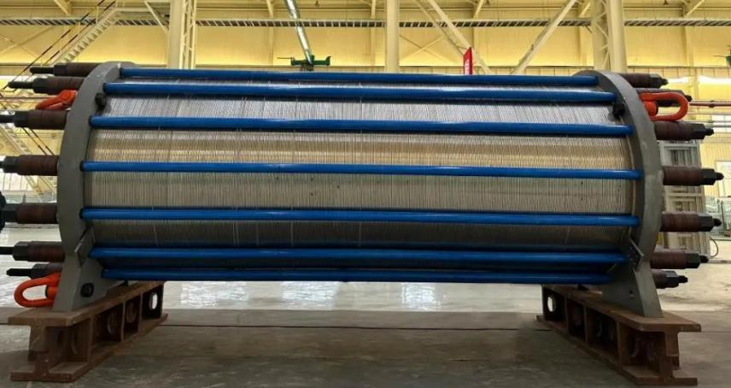

5.1 Special Disc Spring Series for ALK Alkali Electrolysis Cells
Applicable operating conditions: large-capacity industrial alkaline hydrogen production systems, KOH strong alkali electrolyte environments, and medium-to-long-term continuous steady-state operation of equipment; suitable for bolted fastening structures around the electrolyzer tank and at the central main compression point, which provide continuous compensation for creep and thermal expansion/contraction, thereby ensuring stable maintenance of the fuel cell stack sealing pressure.
- Available materials: refined spring steel, 316L corrosion-resistant stainless steel
- Product Advantages: Mature supporting solutions with excellent cost-performance ratio; superior alkali resistance; strict control over creep deformation under long-term operating conditions; supports large-volume stable on-demand delivery.
- Specifications: The entire product series covers all outer diameter specifications; supports any combination of single cells, stacked configurations, or paired configurations; custom matching solutions can be provided based on the customer's stack configuration.

5.2 PEM High-Pressure Electrolyzer Spring Steel Disc Spring Series
Applicable operating conditions: high-pressure hydrogen environments, frequent thermal start-stop cycles, and medium-pressure continuous operation; designed for long-term uniform clamping of proton exchange membrane systems, meeting the clamping requirements of conventional PEM electrolyzers, and mitigating the risk of elastic degradation failure during prolonged operation.
- Available materials: special-grade refined high-quality spring steel, 50CrVA, and 60Si2Mn alloy spring steel
- Product Advantages: Equipped with the Dakro anti-corrosion coating and featuring a standardized surface treatment process that effectively resists moisture and medium-induced erosion; provides stable control over high-temperature stress relaxation, can be paired with membrane electrode insulation treatment solutions, and offers excellent cost competitiveness.
- Compatible models: Small and medium-power high-voltage PEM hydrogen production electrolyzers; distributed hydrogen production PEM electrolysis systems

5.3 AEM Small Distributed Electrolyzer Lightweight Disc Spring Series
Applicable operating conditions: small-to-medium scale distributed AEM hydrogen production systems; designed for scenarios where endplate installation imposes stringent axial space constraints, meeting the requirements for a lightweight overall system design.
- Optional materials: 17-7PH precipitation-hardened stainless steel
- Product Advantages: Thin, lightweight structure enables high load output in confined spaces, with stable performance under both high and low temperature conditions.

5.4 Customized Special Disc Spring Assembly Development
We offer specialized customization services for hydrogen energy applications: self-guided positioning disc springs, insulated-coated disc springs, pre-assembled integrated disc spring assemblies, and ultra-heavy-duty non-standard or custom-shaped disc springs; we support startup development for individual samples and provide concurrent load simulation and combined selection technical support.
- End-to-End Technical Service System

6.1 Preliminary Operating Condition Diagnosis
The standardized on-site investigation process is executed without taking photographs of the customer's equipment drawings or structural blueprints; instead, through structured interviews and on-site observations, information regarding the electrolysis cell stacking configuration, bolt layout, preload, failure points, and acceptance test standards is comprehensively collected. Based on this data, a "Equipment Operating Condition Diagnostic Report" is generated, and a customized disc spring selection scheme is provided.

6.2 Simulation Design Services
- Three-dimensional modeling combined with multi-physics finite element simulation is employed to simulate the stress behavior, creep, and fatigue characteristics of disc springs under high-temperature, high-pressure, and thermal cycling conditions;
- Output load-deformation curves, optimal composite design schemes, and safety factor verification reports to proactively avoid equipment failures resulting from improper selection.

6.3 Samples shall be compatible with the acceptance testing process.
- Quick prototyping: standard specifications with short-term spot delivery; non-standard custom orders with rapid sample production;
- We collaborate with clients to complete the full suite of supplier type approval tests, providing comprehensive internal test reports; where third-party testing is required, we provide full coordination with external testing institutions to shorten the client's supplier audit cycle.

6.4 On-site Technical Support
- Output assembly SOP guidance and pre-torque calibration training;
- Provide recommendations for selecting batch assembly fixtures;
- During the project's commissioning phase, regular follow-up visits are conducted to monitor the long-term creep behavior and pressure decay operational data of the disc springs, enabling continuous iterative optimization of the product.

6.5 Long-term After-sales Technical Services
- Free disassembly analysis of failed components, providing a comprehensive improvement plan;
- Align with industry trends to iteratively upgrade product heat treatment and surface treatment processes;
- Our framework partner clients are assigned dedicated technical liaison engineers who provide 24-hour response to technical inquiries.

VII. Comparison of Supporting Solutions: Sunzo Elastic vs. Overseas Disc Spring Brands
Comparison Dimensions | Overseas disc spring brands | Jiangsu Sunzo  (Specialized disc springs for electrolysis cells) | Customer Comprehensive Benefits
Product procurement cost | High premiums; the overall procurement cost increases by 40%–80%. | Self-developed end-to-end production enables a reduction in unit procurement cost by 30%–50%. | Batch procurement directly reduces material costs.
delivery cycle | Standard parts lead time: 2–3 months; non-standard custom parts lead time: 3 months or more | Standard现货 products are available with fast shipping; non-standard samples can be delivered within a short period; the batch supply cycle is 3–4 weeks. | Aligns with project commissioning milestones, eliminating any risk of delays.
Custom Development Capabilities | We only provide standardized mass-produced components; we do not undertake small-batch customization orders. | Supports custom orders for single items, enabling specialized process optimization tailored for specific operating conditions such as heavy-duty applications or anti-curling requirements. | Addressing scenarios where standardized products cannot be adapted to the operating conditions of specialized equipment
Load Consistency Control | Load tolerance: ±5% | Full inspection and sorting; strict control of load tolerance at ±3%; supported by a precision cone blanking process. | The stack pressure distribution is uniform, thereby reducing energy consumption and minimizing localized overheating failures.
Specialized Material Plan for Operating Conditions | General standardized materials; no specialized optimization for hydrogen energy equipment. | Features an ALK/PEM dual-material system paired with dedicated heat treatment to achieve creep resistance and hydrogen embrittlement resistance. | Extend the bolt retightening cycle to reduce downtime-induced production losses.
On-site Technical Services | Communication is solely via remote email; no on-site engineers are stationed domestically. | Comprehensive end-to-end services encompassing on-site operating condition investigation, simulation analysis, field assembly guidance, and failure analysis. | Eliminates third-party technical consulting fees
Test Report Supporting Materials | Only provides basic factory inspection data. | Complete report for the internal type approval of the full hydrogen energy equipment set; capable of coordinating with third-party institutions to conduct external testing. | Shortening the supplier qualification review cycle to reduce customers' internal testing costs

VIII. Comprehensive performance improvement and cost-reduction benefits of batch installation implementation

8.1 Measured data for improvement of equipment operating performance
- The disc spring load deviation is significantly reduced, the overall pressure non-uniformity across the fuel cell stack is markedly decreased, the electrode plate contact resistance per unit device is lowered, and the operational energy consumption for hydrogen production is optimized;
- Under high-load-limit compression conditions, the extent of high-temperature creep attenuation is significantly reduced, the bolt retightening cycle is substantially prolonged, and the annual downtime for maintenance is markedly shortened;
- The wear-resistant coating on the disc spring effectively prevents the shedding of metal debris, significantly reducing failures caused by electrolyte contamination or insulation breakdown;
- The nickel-based alloy solution effectively mitigates the risk of hydrogen embrittlement-induced fracture under high-pressure hydrogen conditions, significantly extending the theoretical service life of the equipment.

8.2 Project Overall Cost Reduction and Revenue Benefits
- The procurement cost per unit of disc springs has decreased, resulting in substantial annual material savings for mass production projects;
- Significantly reduces the frequency of shutdowns and re-tightening operations, thereby saving annual operational and maintenance labor costs as well as avoiding production downtime losses for each individual piece of equipment;
- Reduces the probability of disc spring fracture and sealing leakage failures, thereby preventing equipment scrapping and safety-related accident losses caused by medium leakage;
- Local production and delivery eliminate long-distance international logistics cycles, thereby reducing inventory holding costs for projects.

IX. Sample Access & Joint Development Standardization Cooperation Process

9.1 Full-process access procedure for supplier samples
- Coordinate with the client's technical team to synchronize electrolyzer operating condition parameters, equipment drawings, and acceptance test standards;
- Provide a simulation-based output selection solution to confirm the disc spring material, dimensions, and stacking configuration;
- Deliver the test samples on schedule, accompanied by a complete internal factory inspection report;
- Collaborate with the client's laboratory to complete the full suite of type tests, and, as required, coordinate with third-party testing institutions to supplement test data;
- Conduct small-batch in-machine comparison and installation testing, followed by continuous monitoring of equipment operational test data for 3 months;
- Complete the customer and supplier qualification review and sign a long-term framework supply agreement.

9.2 Joint Development Cooperation Model
We are opening joint development channels for customers of high-power heavy-duty electrolysis cells and equipment operating under special conditions:
- Both parties shall establish a specialized technical task force to share long-term operational failure data of the fuel cell stack;
- Sunzo has invested in R&D resources to optimize the forming process of disc springs' conical blanks, as well as their heat treatment and surface hardening processes;
- The client provides an installation testing platform to collect long-term creep and fatigue experimental operational data;
- Both parties may jointly apply for utility model patents and invention patents related to hydrogen energy-based elastic components and share the resulting technological achievements;
- Jointly developed finalized products will enjoy priority supply, exclusive pricing, and exclusive technical service rights.
- Summary of Typical Customer Application Scenarios for the Green Hydrogen Equipment Industry

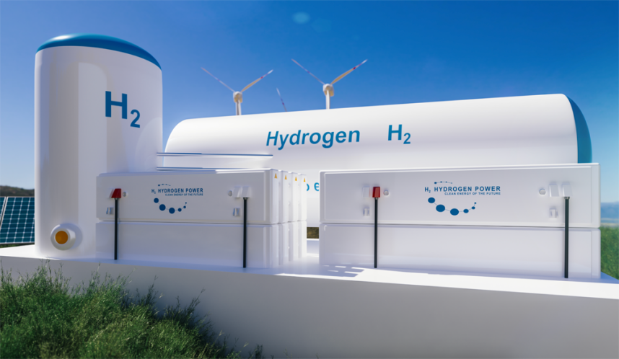
- Large-scale alkaline electrolyzer equipment manufacturers: utilize large-diameter central tensioned laminated disc springs to address key challenges such as high-load creep and poor load consistency, while ensuring compatibility with local equipment supply chains;
- Integrated industrial hydrogen production equipment suppliers: provide standardized bolted mounting solutions featuring disc springs that are resistant to strong alkali corrosion and offer a long fatigue life, designed for supporting large-scale hydrogen production projects;
- High-pressure PEM electrolyzer head equipment supplier: utilizes high-quality spring steel substrates combined with Dacron corrosion-resistant coating, making it suitable for high-pressure hydrogen environments and frequent start-stop operations, thereby reducing the risk of hydrogen embrittlement failure;
- Distributed small-to-medium hydrogen production integrator: AEM lightweight miniature disc springs, designed to accommodate tight end plate installation spaces, ensuring long-term stable mass-producibility supply.

